SIMATS ENGINEERING

Atsayaa.R
(192412024)

Experiment 13

ITA0606
Machine Learning

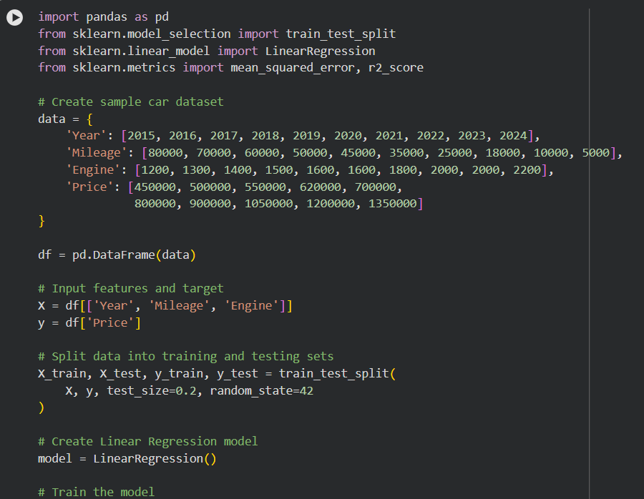
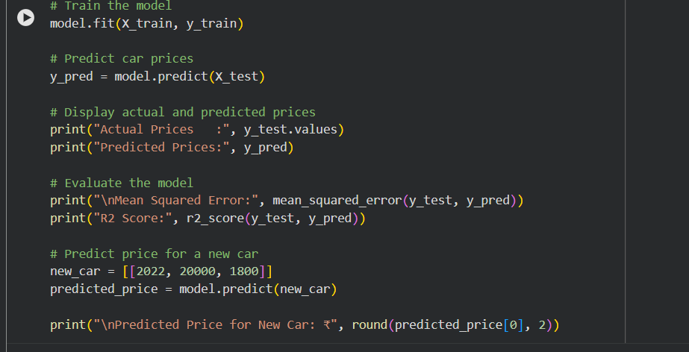
OUTPUT
